Getting Started with SFAS

Shop Floor Deployment Team

Version 1.0

September 2022

# Introduction

This document contains directions for getting started with ***SFAS***. It includes step-by-step directions for:

* Installing SFAS
* Running the Database Installer
* Accessing the SFAS Web Service and Creating a User

# Installing SFAS

Follow the directions below to install SFAS.

1. Access the LIT server where the latest software versions are stored.

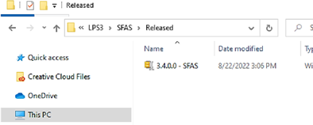

2.

Navigate to

**LPS3>SFAS>Release**

.

3. Copy the latest release package to your local machine. The release package is named **<version**

**number>**

**-**

**SFAS.zip.**

4.

Double

-

click the release

package to open the zip

file to view the files.

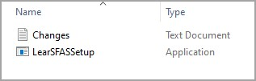

5. Double-click **SFASSetup.exe**. Then click **Run**.

**Note**: Click **Yes** if prompted to grant permission to update your hard drive.

6.

Click

**Next**

to start the

installation wizard.

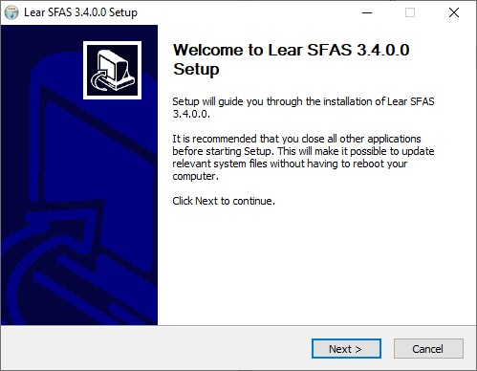

7.

Click

**I Agree**

to accept the

License Agreement.

8.

Enter the installation

location if different than

the default and click

**Next**

.

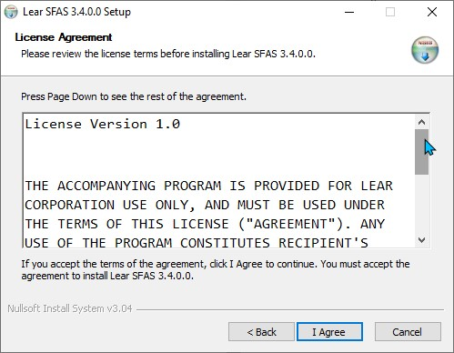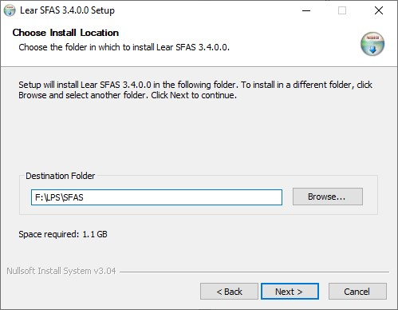

9.

Select the components

**Register Web Application**

and

**Register Service**

, then

click

**Install**

.

10.

The installation begins.

Click

**Next**

when the

installation is complete.

**Note**

:

If you are updating

an existing installation,

you are prompted to back

up the data. Click

**OK**

to

continue.

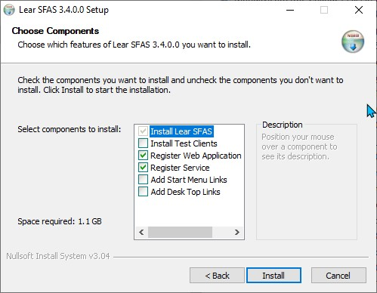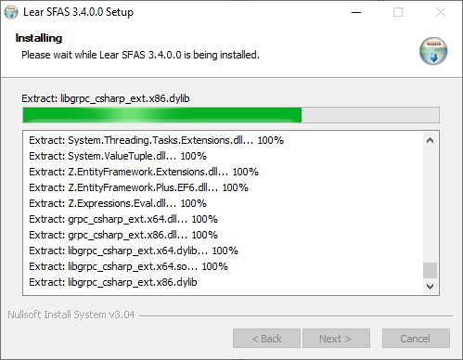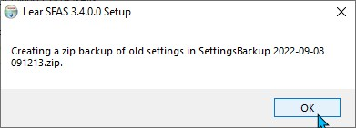

11.

Click

**OK**

to confirm the IIS

Configuration.

12.

Enter the password for

your local service and click

**OK**

.

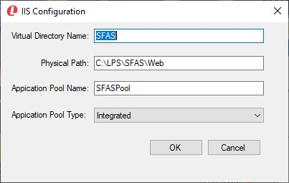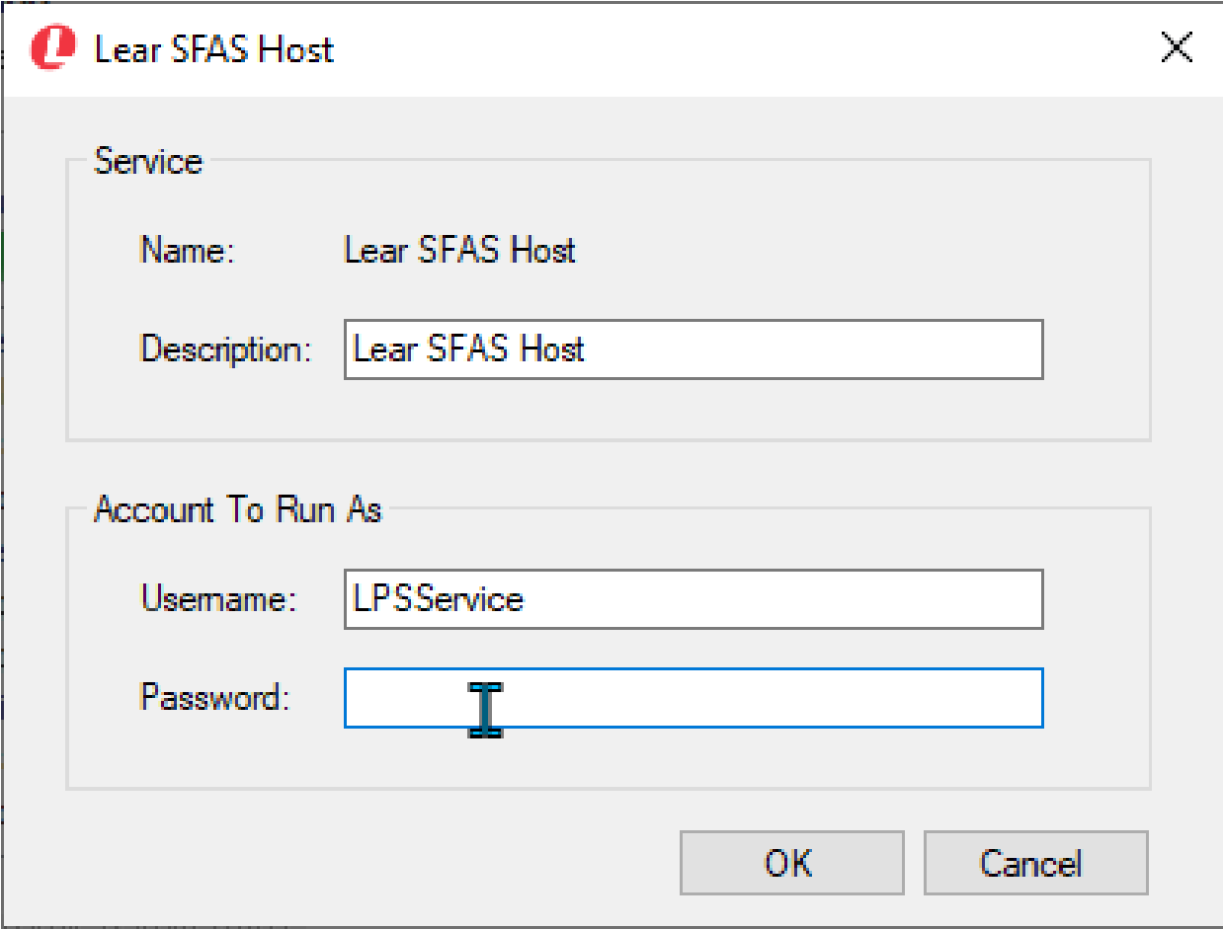

13. Click **Finish** when prompted to close the installation wizard.

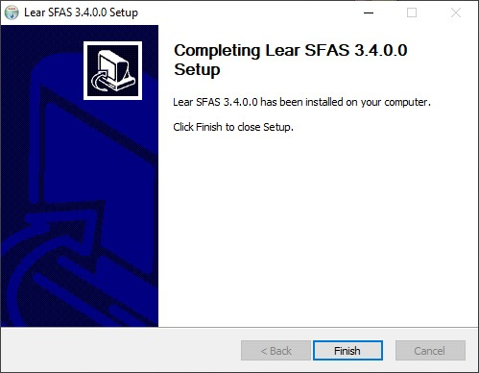

Short cuts are created and located within the install directory.

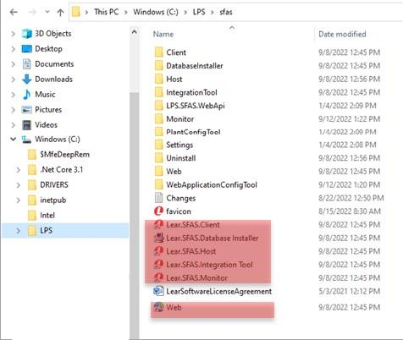

Use the short cuts to access the software instead of the executable files. The short cuts have some flags that enable loading and unloading configurations.

# Running the Database Installer

When you have finished running the SFAS installation wizard, run the database installer.

To run the database installer:

1.

Double

-

click

the

database installer

shortcut

in the

**SFAS**

installation

folder

.

2.

Click

**Next**

to start

the wizard.

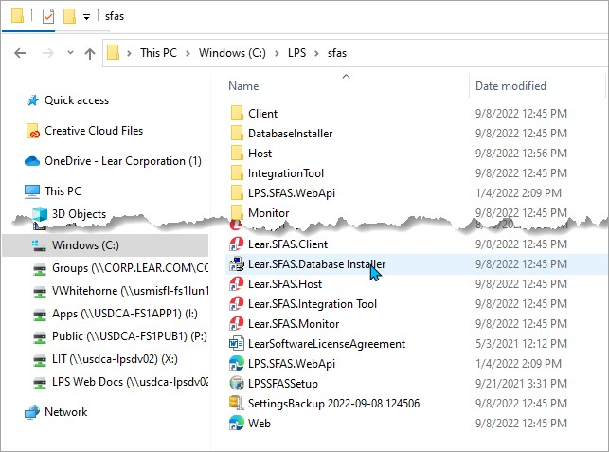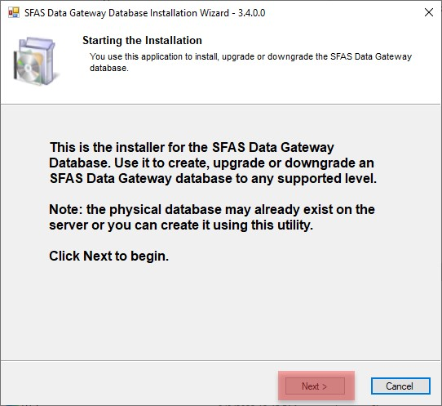

3.

Select the SQL

server you are

using

and

the

authorization type.

If you are using

your local SQ

L

server, you can

enter

**.**

**\**

Click

**Next**

to

continue

.

4.

Click

**Create New**

to create a new

database.

The

***Create New***

***Database***

pop

-

up

window defaults

the name to

**SFAS**

.

You can use the

default or enter a

new database

name.

Click

**Create**

**Database**

to start

gener

ating the new

database.

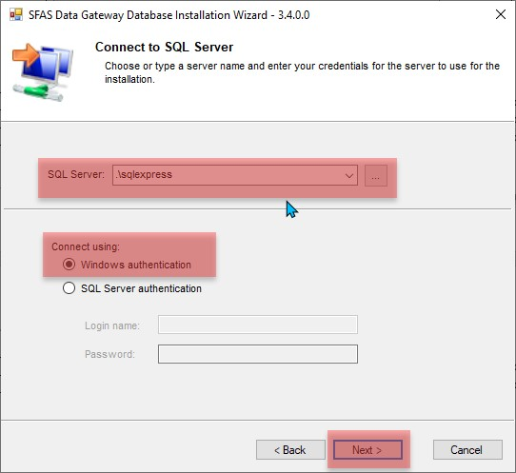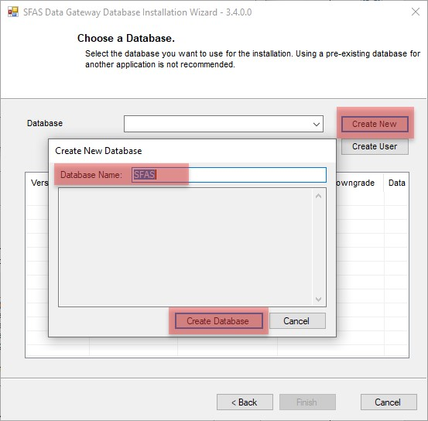

5.

Click

**Done**

when

the database is

created.

A

non

-

configurable

**SFASDataGateway**

**is**

automatically

created

.

You can review the

other activity that

took place

as part

of the database

creation process

in

the pop

-

up

window.

6.

Select the newly

created databas

e

and highlight the

most recent

version.

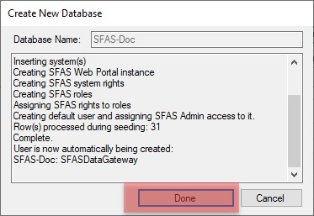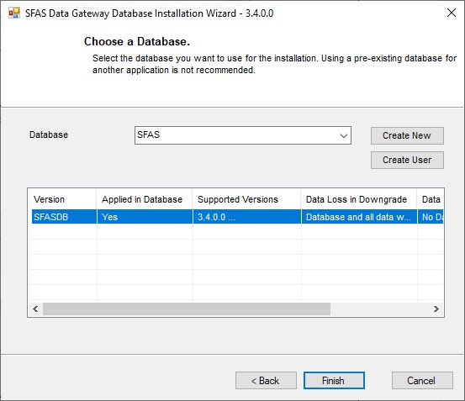

7. Click **Finish** or close the window to complete the database installation.

# Accessing the SFAS Web Service the First Time

To access the SFAS web service for the first time:

1.

Double

-

click the

**Web**

shortcut in the

**SFAS**

installation folder to

open the

***Shop Floor***

***Administration***

***Services***

sign in

window opens.

2.

Complete the

Username and

Password fields.

a.

Enter

**_IU_**

in

Username. fie

b.

Cont

act your

IT

Manager or LPS

Deployment

Specialist for the

Pa

ssword.

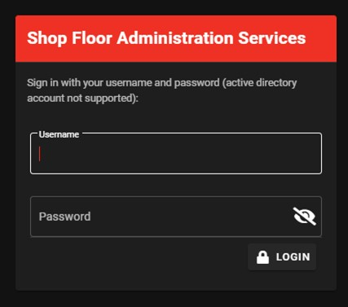

3. Click **Login**.

4.

Click

**Accounts**

**>**

**Accounts**

in

the

***Shop Floor***

***Administration***

***Services***

window

explorer.

5.

Click

**New Account**

in

the

***Account List***

window.

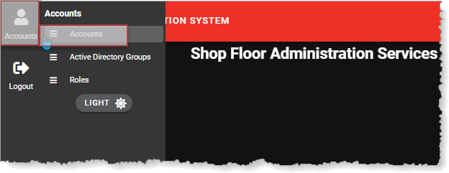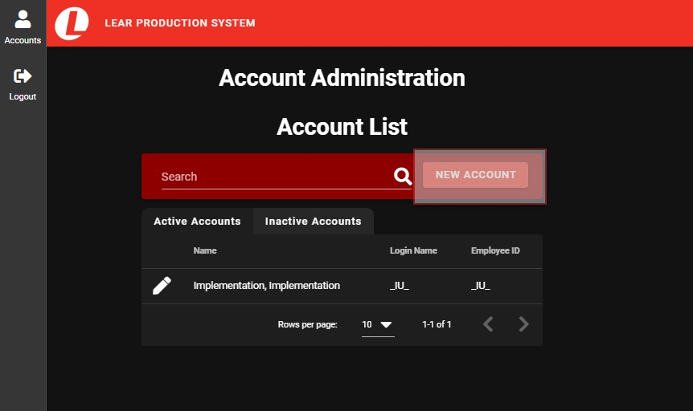

6.

Complete the

**Create**

**Account**

form in the

***Account List***

window.

Click

**Save**

when you

have entered a value

in all fields.

7.

Click

**Close**

when

prompted to create

the account.

8.

The new account is

added to the account

list at the bottom of

the

***Account List***

window.

Click

**Edit**

(

Pencil) to

open the account in

Edit mode

.

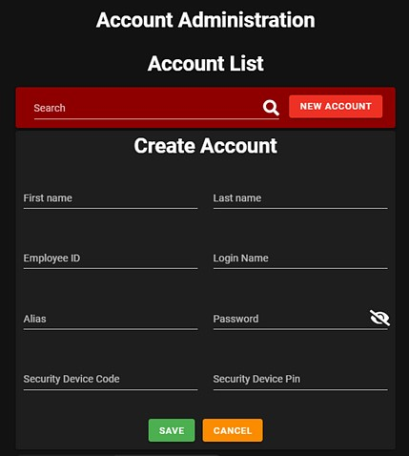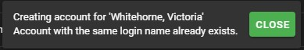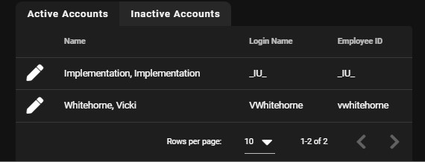

9.

.

Select the check boxes

of each role to assign

to the user and click

**Save**

.

10.

Click

**Close**

when

prompted

.

11.

Click the

**Logout**

icon

to log out of

***SFAS***

.

12.

Login with the account you just created.

